*Train Simulation*

Use Case Specification Document

**Case Id 3**

**Edit Railway**

Version No. 2.0.0

Project Document Revision History

|  |  |  |  |
| --- | --- | --- | --- |
| **VersionNumber** | **Date** | **Revision Author** | **Description of Revision** |
| 1.0 | 3/14/2019 | Brendan Batchelor | Brendan Batchelor completed:  1.) Introduction  2.) Use Case Information  3.) Trigger  4.) Preconditions  5.) Postconditions  6.) Use Case Swimlane (Activity) Diagram  7.) Main/Basic Flow(s) of Events (Happy Path)  8.) Alternate/Exception Flow of Events  9.) Assumptions/Business Rules including Non-Functional Requirements  10.) Use Case Specification Review and Signoff |
| 1.0.1 | 3/17/2019 | Brendan Batchelor | Updated actors and swimlane diagram |
| 1.0.2 | 3/18/2019 | Brendan Batchelor | Added Project document revision history  Removed 10.  Added TOC page numbers |

Table of Contents

**1. Introduction** **4**

**2. Use Case Information** **4**

2.1 Actors 4

2.2 Use Case Interaction 4

**3. Trigger** **5**

**4. Pre-condition(s)** **5**

**5. Post-Condition(s)** **5**

**6. Use Case Swimlane Diagram** **6**

**7. Main/Basic Flow(s) of Events** **7**

**8. Alternative/Exception Flow of Events** **7**

**9. Assumptions/Business Rules including Non-Functional Requirements** **7**

# **1. Introduction**

This case and the associated tools will allow the user to modify the railway layout. This includes the ability to create and delete track connections, stations, and hubs. This may be done before each simulation aside from the first. The weight of new track pieces will be determined by the user  ~~two endpoints’ positions.~~ A station/hub may not have its final track connection removed without another being placed. The user may not delete the last station or last hub.

# 2. Use Case Information

## 2.1 Actors

|  |  |  |
| --- | --- | --- |
| **Actor Name** | **Role** | **Description** |
| User | Main Actor | Engages editing mode and decides which changes are to be made. |
| Simulation System | Secondary Actor | Rejects invalid changes. Saves all changes upon the exit of editing mode. |
| UI System | Secondary Actor | Updates changes made to the graph visually as they are done by the user. |

## 2.2 Use Case Interaction

**A list of predecessors use cases are as follows:**

Case 1: Setup Initial State – To reach the editing stage of the program, a railroad must be loaded.

Case 4: Adjust Weather Options – Both successor and predecessor. Part of case 6.

Case 6: Run Simulation – Must happen once before the railroad editing tools are unlocked.

Case 7: Track Statistics – See above. Statistics may be used during editing by user.

Case 8: Recommend Changes – Must happen once before the railroad editing tools are unlocked.

Case 9: View Statistics – Optional. User is advised to do this step before editing the railroad.

**A list of successors use cases are as follows:**

Case 5: Update Graph – After editing the railway, the railway graph representation will need to reflect the changes made.

Case 2: Add/Remove Trains – Addition or removal of trains will be allowed only after the railroad layout has been completed.

Case 10: Rollback Simulation History – This is the final step in the program, it logically comes after all other use cases.

# 3. Trigger

Access to editing tools is unlocked after the user has run the simulation at least one time, and gone through all of the predecessor actions that come after a simulation.

# 4. Pre-condition(s)

4.1 Simulation iteration #1 has been completed or paused, and both its statistics and recommended changes have been acknowledged by the user.

# 5. Post-Condition(s)

**5.1:** After the user has finished editing the railway, the changes made are saved and the graph representation will be updated.

**5.2:** At this point the user may return to editing, move to use case 2 (Edit trains), use case 6 (Run simulation), use case 4 (Adjust weather options), or use case 9 (View Statistics)

**5.3:** Error messages if they have any did anything wrong.

# 6. Use Case Swimlane Diagram

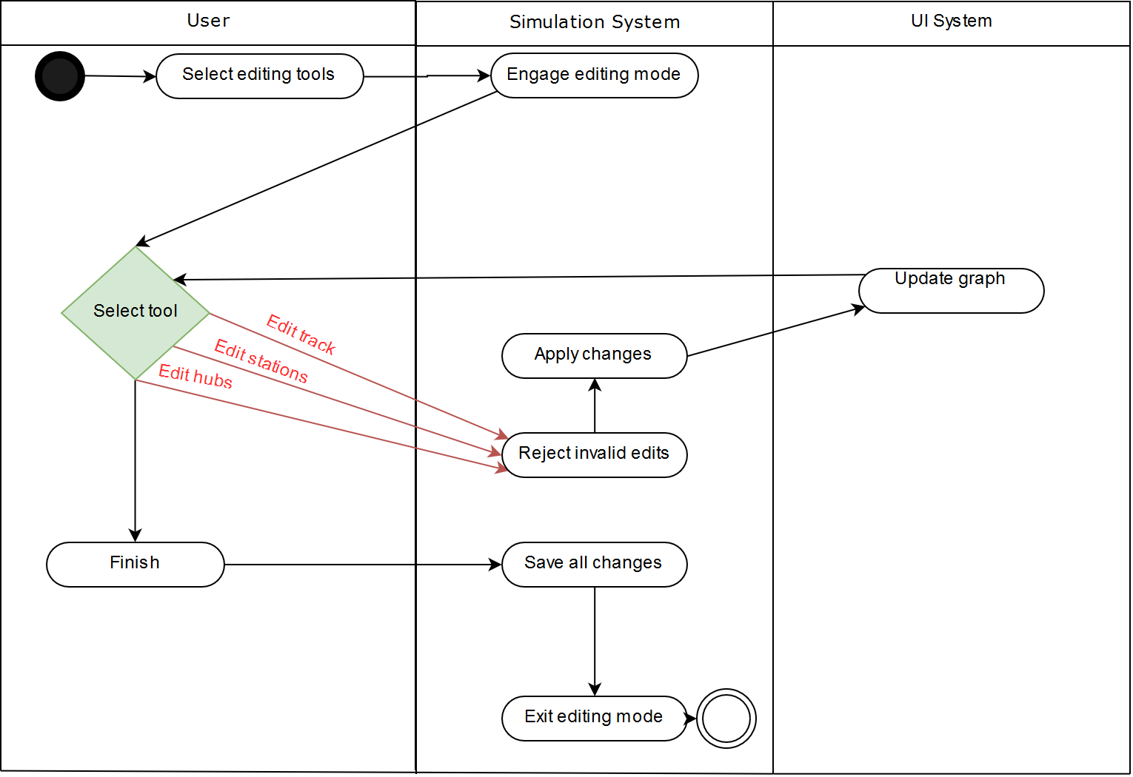

# 

# 7. Main/Basic Flow(s) of Events

**7.1:** A simulation ends and the user acknowledges the information conveyed at the end. The UI returns to the pre-simulation state but with railway editing tools unlocked. The user may choose to open these tools to enter railway editing.

**7.2:** The user may edit the railway in three ways in no particular order. The user may make all three types of edits in any order while using the editing tools.

**7.2.1:** Add/Remove track. This tool allows the user to define which stations or hubs are linked by track by using the UI.

**7.2.2:** Add/Remove stations. Allows the user to remove existing stations or place a new one at a coordinate relative to another station/hub. ~~User may not reduce the number of stations to 20.~~

**7.2.3:** Add/Remove hubs. Allows the user to remove existing hubs or place a new one at a coordinate relative to another station/hub. ~~User may not reduce number of hubs to 5.~~

**7.3:** After the user is satisfied with their edits, the editing tools may be closed at any time, saving all changes. The user may choose to do other activities afterward or return to editing mode again if they need to.

# 8. Alternative/Exception Flow of Events

**~~8.1:~~** ~~User may not reduce number of stations to 20~~

**~~8.2:~~** ~~User may not reduce number of hubs to 5~~

# 9. Assumptions/Business Rules including Non-Functional Requirements

**9.1:** UI will update to changes as they are made

**9.2:** User will be notified of invalid change attempts (deleting last station, etc.)

**9.3:** User cannot back out on a change once it is made